To Automated Facebook Sign Up Process Selenium script.

Steps to be performed:

1 Open the Chrome Firefox Safari browser.

2 Navigate to the Facebook website (her facebook.com).

3. Verify that the website has been redirected to the Facebook homepage.

4. Click on the "Create new account" button.

5. Enter the first name as "Test" and last name as "User" in the respective fields.

6. Enter a valid email address (for example, testuser@test.com) in the email field.

7. Enter a strong password in the password field.

8. Select the date of birth as 111 month as "May and year as "1985" using the drop-down

menus.

9. Select the gender as "Male using the radio button”.

10. Click on the "Sign Up" button.

11. Verify that the user is successfully registered on Facebook and redirected to the Facebook homepage.

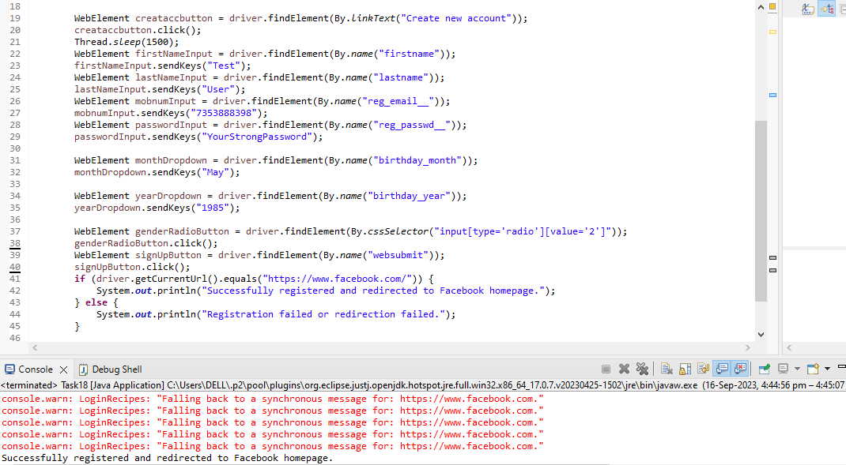

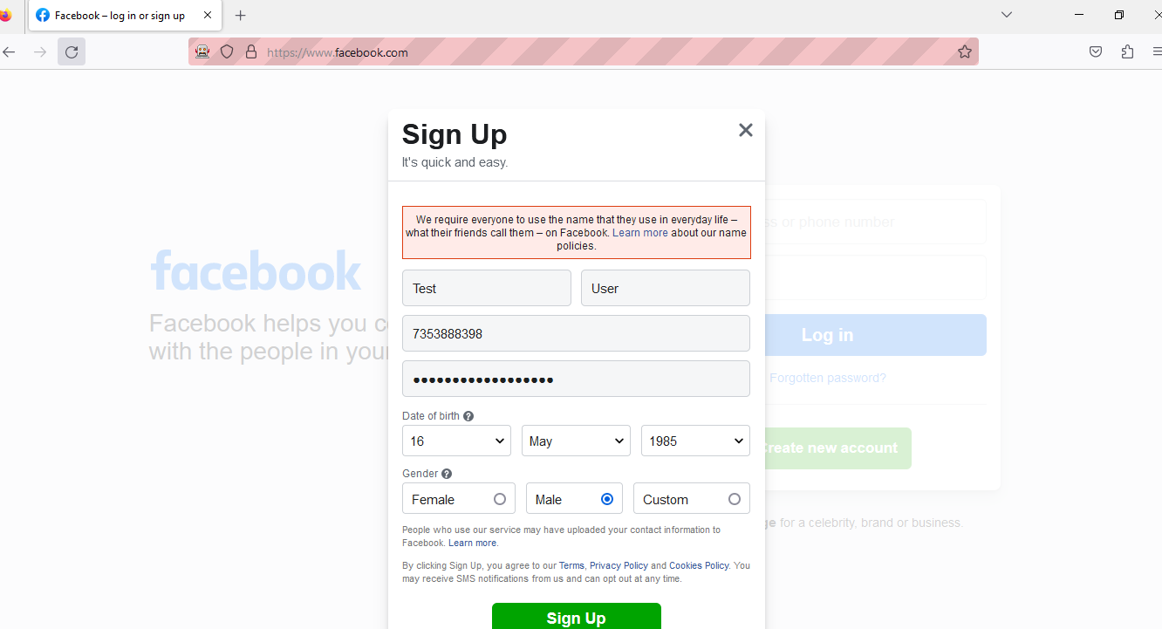

2).To Automated Drag and Drop Operation using Selenium Java.

Steps to be performed:

1. Open the Chrome/Firefox/Safari browser

2. Navigate to the jQueryUI droppable website (https://jqueryui.com/droppable).

3. Find the source element with the text "Drag me to my target" and the target element with

the text "Drop here".

4. Perform the drag and drop operation from the source element to the target element

5. Verify that the drag and drop operation is successful by checking the color property of the

target element's CSS

6. Verify that the text of the target element has changed to "Dropped!" after the drop.

